**Project Initialization and Planning Phase**

| Date | 10/11/2024 |
| --- | --- |
| Team ID | team-739757 |
| Project Name | Tomato Plant Disease Detection from Leaf Images Using Deep Learning |
| Maximum Marks | 3 Marks |

**Define Problem Statements (Customer Problem Statement Template):**

Tomato farmers struggle with early and accurate disease detection, leading to crop loss and financial setbacks. Traditional methods are time-consuming and unreliable. This project aims to develop a deep learning tool that uses leaf images to quickly and accurately identify tomato plant diseases, enabling timely intervention and improving crop yield**.**

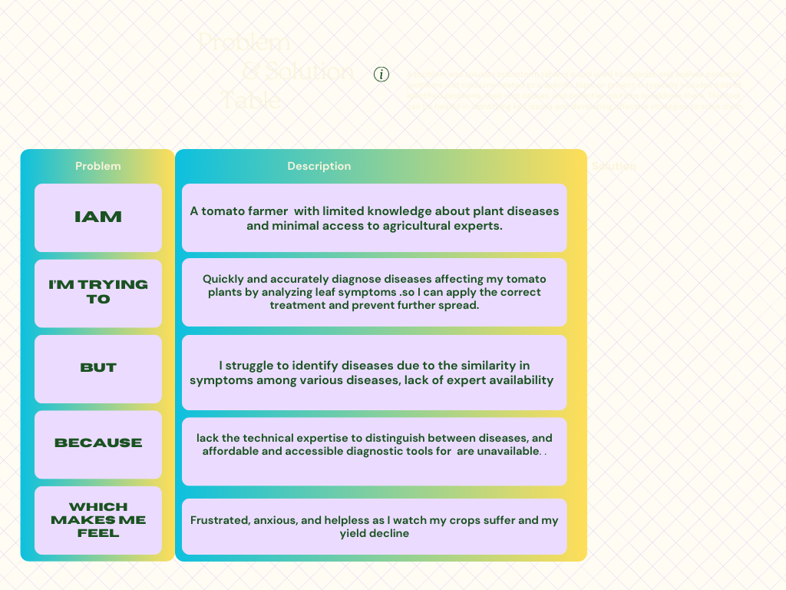

**Example:**

|  |  |  |  |  |  |
| --- | --- | --- | --- | --- | --- |
| **Problem**  **Statement (PS)** | **I am**  **(Customer)** | **I’m trying to** | **But** | **Because** | **Which makes me feel** |
| PS-1 | A tomato farmer | |  | | --- | | Identify diseases on my tomato plants early |  |  | | --- | |  | | The disease symptoms are often hard to spot manually | Early detection is crucial to save the crop and minimize losses | Anxious and worried about potential crop loss |
| PS-2 | An agricultural expert | Use technology to aid farmers in disease diagnosis | Current methods are time-consuming and often unreliable | The lack of accessible and accurate disease prediction tools in the field | Frustrated and concerned about the efficiency of existing solutions |